SRDL Playbook Instructions

**Important Links:**

**ALL SPORTS:**

[**DSG_OnAirV3_PlaybookPages.xlsx**](https://docs.google.com/spreadsheets/d/1sIu96wxA6l9DdptrIS6EbJTFdz9yTkWb/edit?usp=drive_link&ouid=115027571766694038024&rtpof=true&sd=true) **- This Google Sheets document contains all the available SRDL pages currently generated. Features a description along with the base page and write to page for each graphic.**

[**PLAYBOOK-READ_v2.2.txt**](https://drive.google.com/file/d/1LX6LNNQ5b_XJnr0k8iSiMOYo0kNWdyHv/view?usp=drive_link) **- This viz script macro mimics the SRDL Page Builder macro of previous seasons. Once the file generated from OnAirV3 is pasted into the C:\PlaybookPageBuilder folder you type in the write to page number you want to build and press the macro to have it build in preview. This macro typically lives on the read button but can also be placed elsewhere.**

[**Playbook_DELETE-Page-Generation.txt**](https://drive.google.com/file/d/1MwvW7IM7YwospV9iG_HSu4gUZPwWWYv-/view?usp=drive_link) **- This viz script macro deletes all SRDL-generated pages. It should be used before or after a show is completed.**

[**PLAYBOOK-READ-BASEPAGE_v1.txt**](https://drive.google.com/file/d/1pmMha0Hjr_SUQdLDWBTVsxLNdVT3OGJ6/view?usp=drive_link) **- This macro when triggered after building a SRDL page will call up the base page that was used to build the page.**

**NBA**

[**DSG NBA Playbook 10-03-24.sr**](https://drive.google.com/file/d/1rcDjV_fd495M4l-rA9Vs9YJ3VJsOsbOM/view?usp=drive_link) **- SR backup file that needs to be imported into OnAirV3**

[**NBA Playbook Base 10-03-24 v1.XML**](https://drive.google.com/file/d/1m_keaUjtdym346ZMEcyH7K7VA8dOVN41/view?usp=drive_link) **- Base Page XML file that needs to be imported into NBA Trio Show.**

**NHL**

[**DSG NHL Playbook 09-27-24.sr**](https://drive.google.com/file/d/1R8WHmSSA3M4yumM31o1HXQAYVfYlWHno/view?usp=drive_link) **- SR backup file that needs to be imported into OnAirV3**

[**NHL Playbook Base 9-27-24.XML**](https://drive.google.com/file/d/18cW9KCz0ohetBQDx2HYsNwXlKEqbkl73/view?usp=drive_link) **- Base Page XML file that needs to be imported into NHL Trio Show.**

**INSTRUCTIONS**

1. **Download either the NHL or NBA Playbook .SR file above.**
2. **Log into the following link with your OnAirV3 Credentials.** [**https://onair.sportradar.com/matchup**](https://onair.sportradar.com/matchup) **if you don’t have credentials please reach out to Andrew Benninghoff at** [**andrew.benninghoff@ballysports.com**](mailto:andrew.benninghoff@ballysports.com)

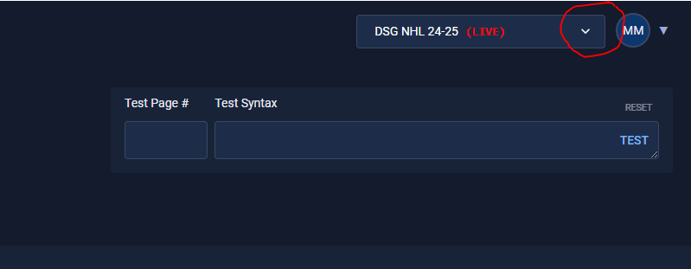

1. **Click the down arrow on the top right of the OnAirV3 interface.**

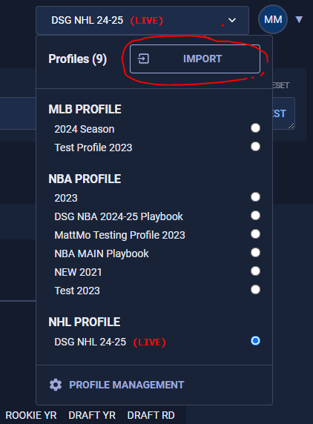

1. **Select the radial button of the profile you are trying to update and click the import button.**

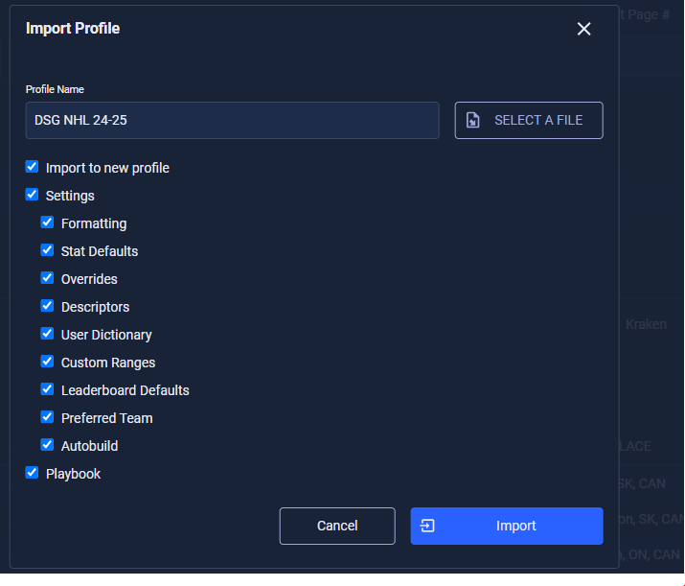

1. **If you want to import everything as is and import it as a new profile leave all options checked and press the blue import button.**

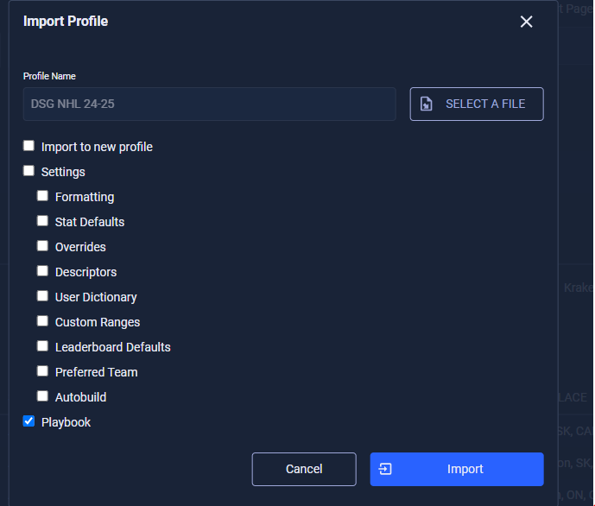

1. **For NHL Operators who simply want to import the playbook section into an existing profile in order to not lose custom user dictionary and range entries, deselect everything except playbook like so. Press the blue import button.**

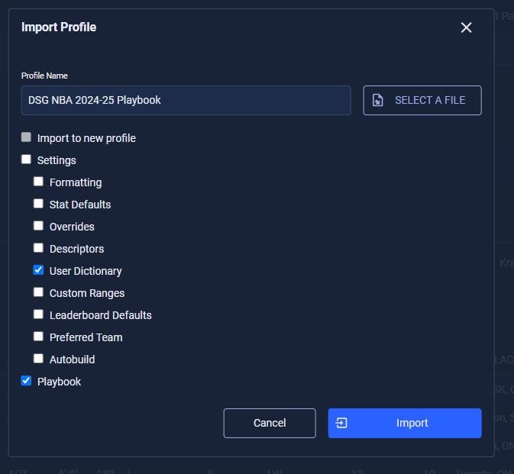

1. **For NBA Operators who simply want to import the playbook section into an existing profile, you will need to import the playbook section and the User Dictionary section. This is because the playbook section references user dictionary items. This means you want to take pictures of your current user dictionary section to easily recreate them afterward.**

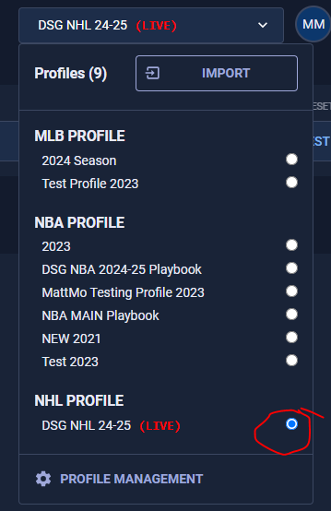

1. **Click the dropdown to select the recently imported profile.**
2. **Click the Profile Management button at the bottom of the list and ensure the same profile is set as live there.**

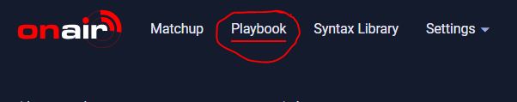

1. **Click the Playbook button at the top left of the interface.**

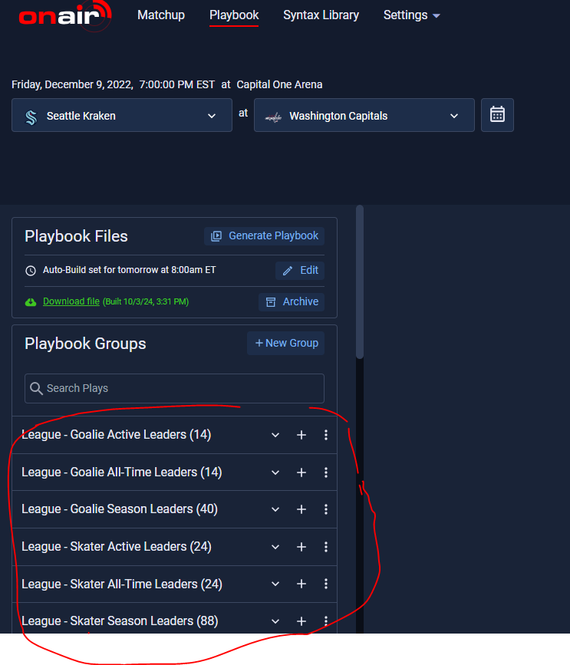

1. **Assure you have a list of sections of SRDL graphics like the above picture. If not, you should try importing the profile again.**

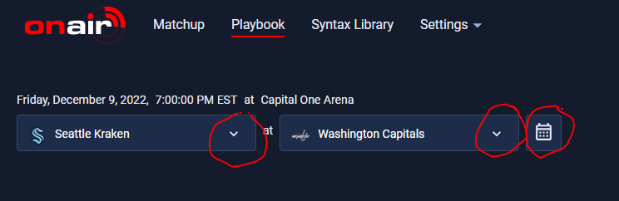

1. **Select the matchup from the calendar or manually set the teams facing each other.**

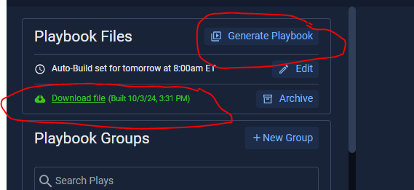

1. **Click the Generate Playbook button and wait 5 minutes for the Green Download File Text to appear. Download the file by left-clicking on the Download file text.**

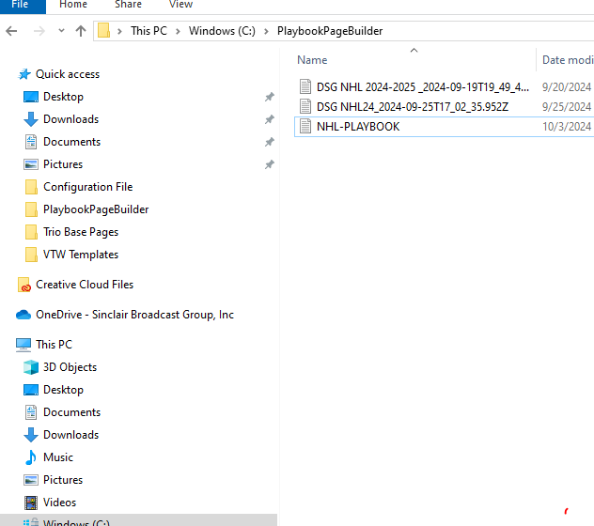

1. **Create a folder in the root of the C Drive called PlaybookPageBuilder and copy and paste the downloaded file into that newly created folder**
2. **Download the base pages for your sport and import it into your trio show.**

[**NBA Playbook Base 10-03-24 v1.XML**](https://drive.google.com/file/d/1m_keaUjtdym346ZMEcyH7K7VA8dOVN41/view?usp=drive_link)

[**NHL Playbook Base 9-27-24.XML**](https://drive.google.com/file/d/18cW9KCz0ohetBQDx2HYsNwXlKEqbkl73/view?usp=drive_link)

1. **Download, open, and copy the entire** [**PLAYBOOK-READ_v2.1.txt**](https://drive.google.com/file/d/1LX6LNNQ5b_XJnr0k8iSiMOYo0kNWdyHv/view?usp=drive_link) **file.**

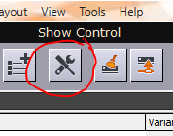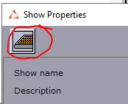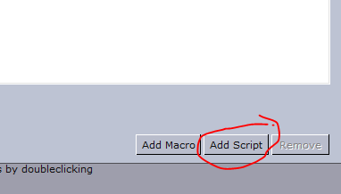

1. **In Trio click the Show Properties button and then click the macro key at the top left then click on the add script button at the bottom right.**

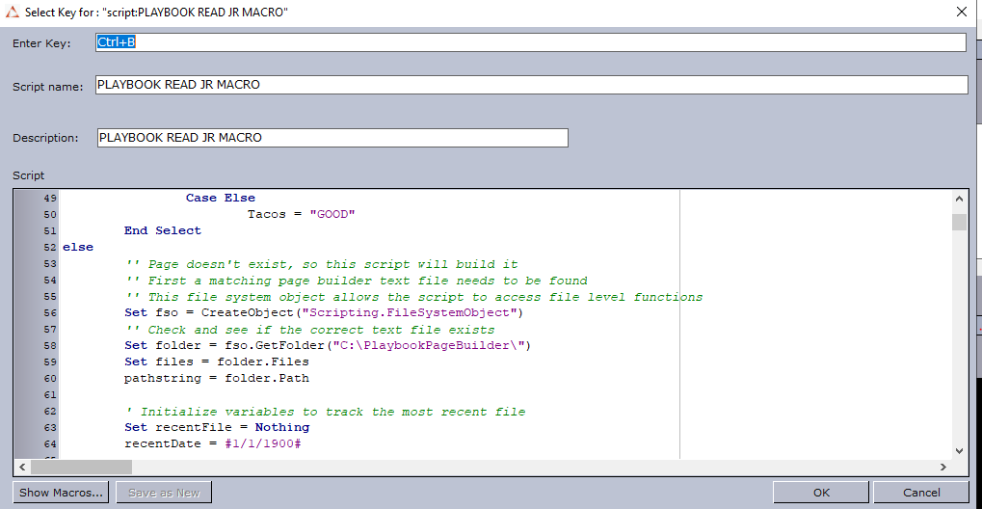

1. **Paste the entire Playbook Read macro into the script section and assign it a button by clicking in the enter key section and clicking whatever button you want it to be triggered by. This was designed to override the read button but it’s not completely necessary to have it there.**
2. **While you are here, download and copy over the following script macros and assign them to a button just like you did for the previous macro.**
   1. [**Playbook_DELETE-Page-Generation.txt**](https://drive.google.com/file/d/1MwvW7IM7YwospV9iG_HSu4gUZPwWWYv-/view?usp=drive_link)
   2. [**PLAYBOOK-READ-BASEPAGE_v1.txt**](https://drive.google.com/file/d/1pmMha0Hjr_SUQdLDWBTVsxLNdVT3OGJ6/view?usp=drive_link)
3. **Next access the** [DSG_OnAirV3_PlaybookPages.xlsx](https://docs.google.com/spreadsheets/d/1sIu96wxA6l9DdptrIS6EbJTFdz9yTkWb/edit?usp=drive_link&ouid=115027571766694038024&rtpof=true&sd=true) **for both NBA and NHL pages or the NHL reference sheet here:** [SR NHL Playbook Library.docx](https://docs.google.com/document/d/1jQTJbEGku4P6XOlPnzjBcGLiREbgxXP4/edit?usp=drive_link&ouid=115027571766694038024&rtpof=true&sd=true)**or the NBA reference sheet here**[SR NBA Playbook Library.docx](https://docs.google.com/document/d/1DoOQm2UKYd2kEoEIQwrrT5ja0UbECN_o/edit?usp=drive_link&ouid=115027571766694038024&rtpof=true&sd=true) **to figure out what page number to build.**

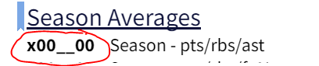

1. **Find the graphic line you want to build and replace the x with a 1 for away to 2 for home and then the __ with the player's jersey number. So for an away player with jersey number 17. the number for the above graphic would be 1001700.**
2. **Type that into the queue in Trio and Trigger the Playbook Read Macro. Your page should have been generated in the Preview window. If not ensure you have the required playbook file in the PlaybookPageBuilder folder on the C Drive.**
3. **If you need to make a slight adjustment to the base page and change where the data is being delivered you can use the** [**PLAYBOOK-READ-BASEPAGE_v1.txt**](https://drive.google.com/file/d/1pmMha0Hjr_SUQdLDWBTVsxLNdVT3OGJ6/view?usp=drive_link) **macro to trigger after running the playbook page builder macro. This will pull up the base page that was used to build the srdl-generated page.**
4. **At the end of the show make sure to trigger the** [**Playbook_DELETE-Page-Generation.txt**](https://drive.google.com/file/d/1MwvW7IM7YwospV9iG_HSu4gUZPwWWYv-/view?usp=drive_link) **macro which will delete all the generated pages allowing you to start fresh for the next show.**

**If you have any questions or issues with any of these instructions please reach out to Matt Mohebalian at mcmohebalian@livesportsanywhere.com**