**How to load the VTW Template**

1. Download the latest VTW template found in the [VTW Template Google Drive Folder.](https://drive.google.com/drive/folders/1e3oKXEMkkJKYhZ0-Mj_I_mWzg0B6qXuC?usp=sharing)
2. Import the VTW Template into your show by clicking the Show Properties button.
3. Find the Active VTW template dropdown and click the ellipses to the right.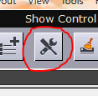
4. Click the folder to browse for the VTW template you downloaded from Step 1.

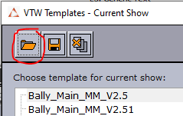

1. After selecting and opening the vtw template file, it should populate in the VTW template list. Select the file from the list and press ok. You should then see the name of the new vtw template in the Active VTW Template Dropdown of the Show Properties window. Press Ok one last time and the VTW should be properly loaded.

**Using the VTW Template to display Win Probabilities Nub**

1. Click on the VTW Template Win Prob Tab.

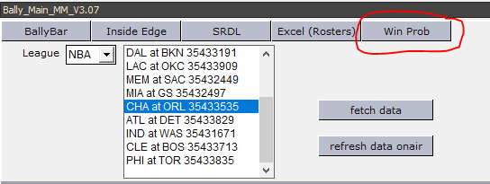

1. Click on the League Dropdown to select your league.

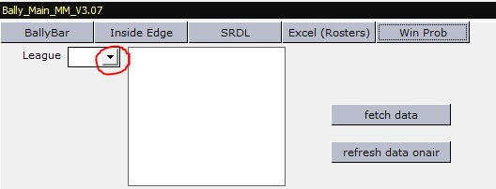

1. A list of games for the next two days should populate to the right of the league dropdown.

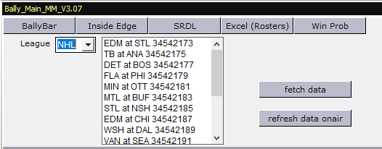

1. Click on a line in the games list to bring up the NU_WinProb template with Win Probability data for the chosen matchup.

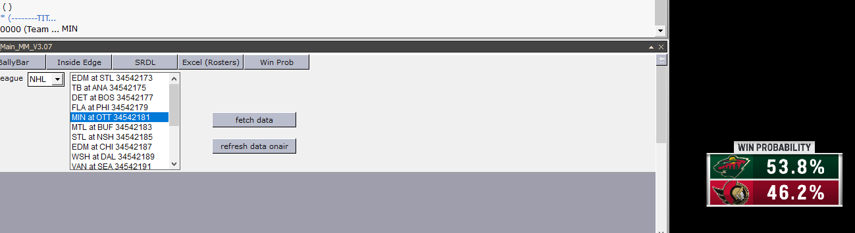

1. The data updates on the Sportradar update every 10 seconds, to refresh the data in the preview window press the fetch data button or simply click the line in the game list again.

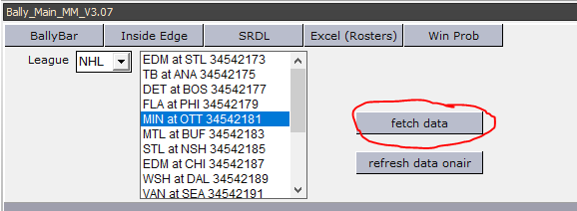

1. If you want to update the win probability graphic on air simply fetch the data again and then press the refresh data onair button (this button is triggering the Page:Update viz command which simply updates the data on the engine without animating out the graphic.

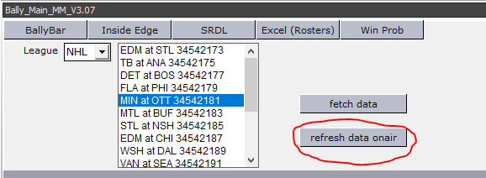

**Using the VTW Template with Excel Roster Spreadsheet**

1. After customizing the ROSTER_Excel_V3.xls spreadsheet save the xls file. A picture containing table

   Description automatically generated
2. Save the **L3_Bio** scene to trio page 7800 and 8800 and the **FS_PlyrStat** combo page to 7600 and 8600 or simply import [this XML](https://drive.google.com/file/d/1Nc5g4RQUc-8fGDEKq_BSPGrhFjmoQ22L/view?usp=sharing) into your show.

1. Click the Excel (Roster) button at the top of the VTW template.

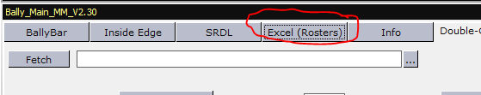

1. Next to the Fetch button you will see a text box for the Roster_Excelv3 filepath. You can manually enter it or browse for the file by clicking on the ellipses button to the right of the drop down.
2. Click the Fetch button to load the excel and wait for the “loading…” text to disappear. The text “Loaded Excel” should appear within 3 seconds.
3. Select the player Bio you want to create by selecting the player from the Away Roster or Home Roster drop down list.
4. After selecting the player you would like to feature from the list, press the button to the right of the dropdown called “FS – 7600/8600” to build a full screen graphic or “L3-7800/8800 to build a lower third graphic.
5. Save page or save as a different number for use later.
6. You will notice two new buttons above the home and away roster dropdown which will allow you to autobuild every home and away player’s L3_Bio or FS_PlyrStat starting at a page you specify. To start building on the current loaded page simply double click on one of the input boxes and the current page number will populate into the box. Be advised this process will take around 30-45 seconds to complete. The “Building..” text below the Build All Button will disappear once finished.

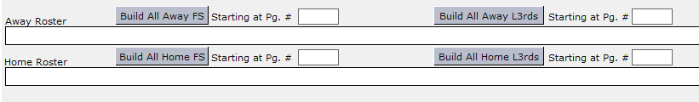

**Custom linking to the Excel Sheet Columns**

1. With this new VTW we’ve added the ability for custom linking to excel sheets so you don’t need to simply accept how we think the L3_Bio or FS_PlyrStat should be built, to do so start by loading any viz template and scroll lower on the vtw template to the following section:

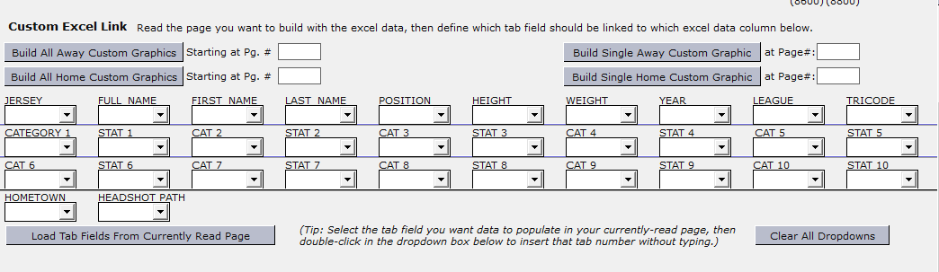

1. To build a custom linked graphic for just one player start by selecting the player from the away or home dropdown.
2. Press the Load tab fields from currently read page button at the bottom of the vtw template.
3. You’ll notice that the 30 dropdown lists correspond with the Excel Column Headers. There are 3 ways to link the excel column with the tab field.
   1. Manually Type the Tab field name meant to be populated under the correct header
   2. Use the dropdown list under the excel header to select the correct tab field name.
   3. If the tabfield is currently highlighted simply double click in the input box under the correct header to populate it with the currently highlighted tab field name.

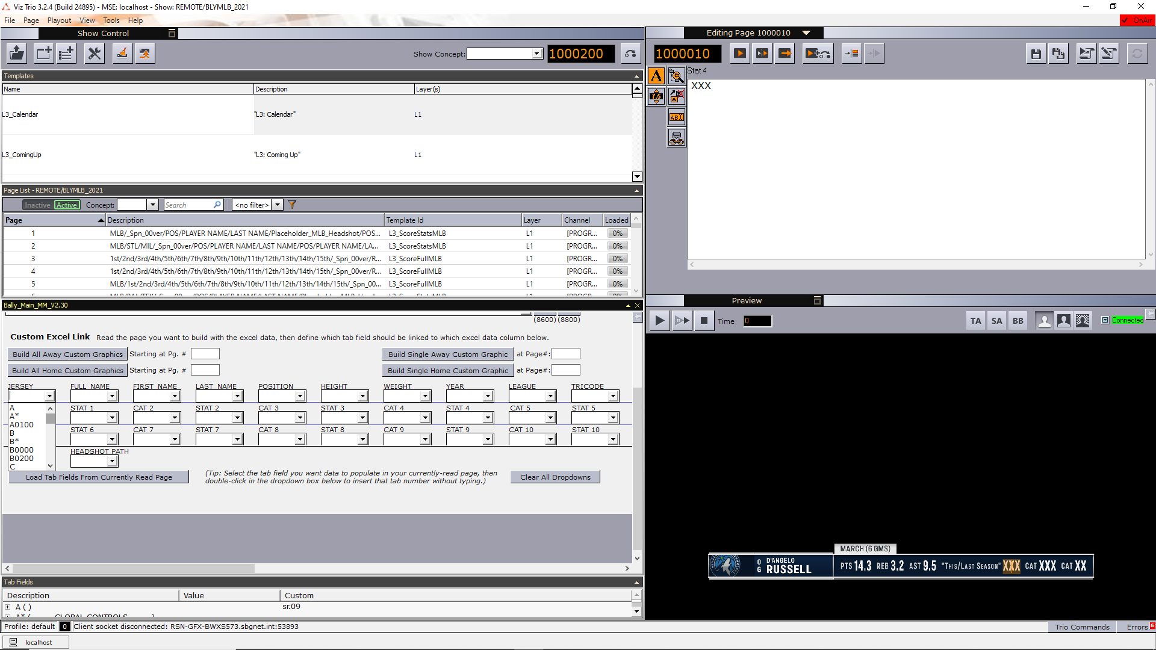

1. Next to the Build Single Away Custom Graphic button you will see text that reads “at Page#” and then an input box. Type in the page you want to build to or simply double click if you have the page you intended to build to called up and the currently read page number will automatically populate in the input box.

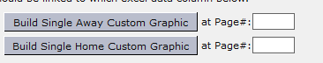

1. Once you have selected a player from the dropdown list and every tab field you would like to be linked entered into the dropdowns and have defined a page for it to live at press either the Build Single Away Custom Graphic button or Build Single Home Custom Graphics button.
2. If you would like to build a custom linked graphic for every single player on the away or home roster you can simply use the Build All Away Custom Graphic or Build All Home Custom Graphic. Similar to the single custom graphic button you will just need to define a page to start building to. Keep in mind this will take 30 seconds to a minute to complete.



1. Press the Clear All Dropdowns or press load tab fields from currently loaded page to populate the Excel Header dropdowns with the currently read pages tab fields.